1. Tools versions
2. How to download project on your local environment (laptop, PC)
3. How to setup database (Pgadmin 4, cmd, application.yml configuration)
4. Liquibase contexts
5. Additional information

1. Tools versions

Java → 11
PostgreSQL → 14.2
Maven → 3.8.5
Git → 2.35.1

2. How to download project on your local environment (laptop, PC)

Repo link:
https://github.com/bartlomiejchojnacki1/stazproj1

1. Click on “Code” button
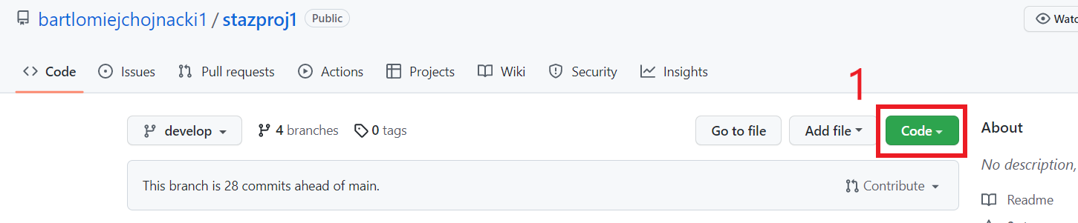
2. Click on button to copy Https link to repo
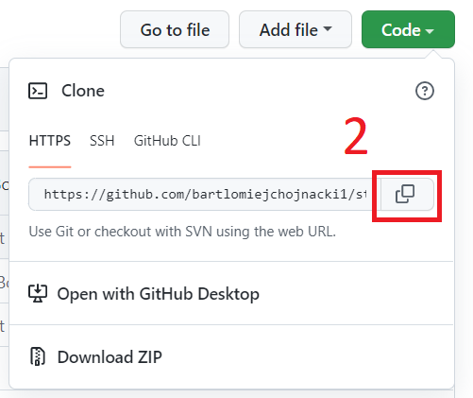

3. Go to folder where you want your project, click ppm and choose git bash option
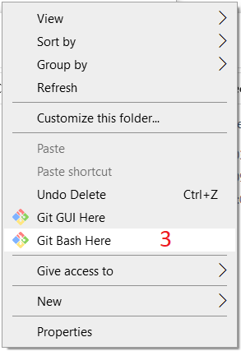

4. Use git commit command

That’s all. Project folder should now be accessible

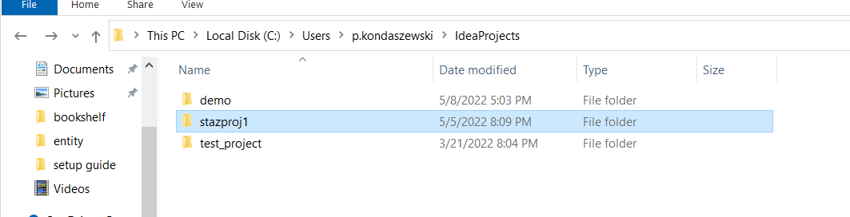

3. How to setup database (Pgadmin 4, cmd)
- Pgadmin 4

1. Log on PostgreSQL account and server with your passwords

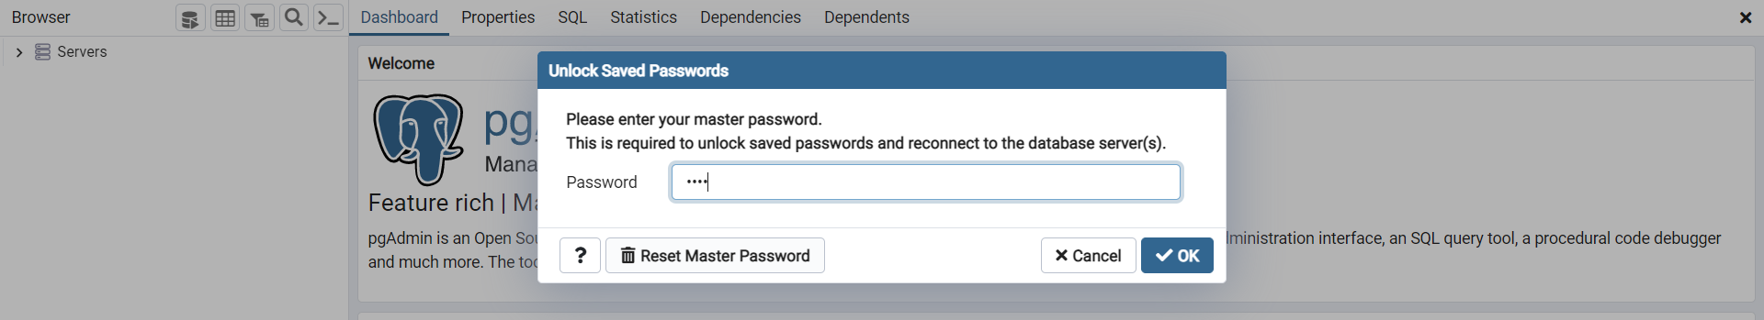

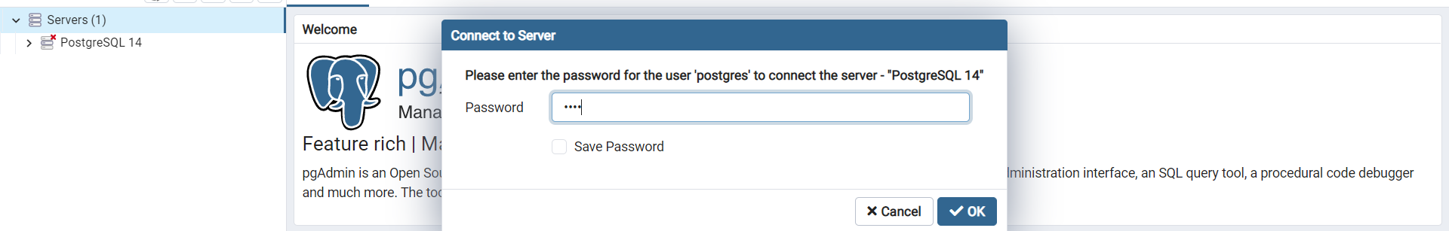
2. Create two new database with name “bookshelf” and “bookshelfuser”

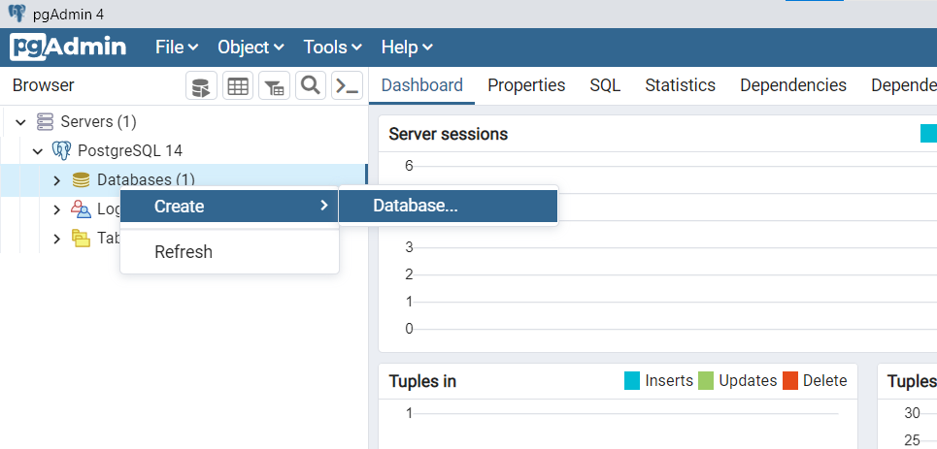

Name of the database has to be ‘bookshelf’ and “bookshelfuser”
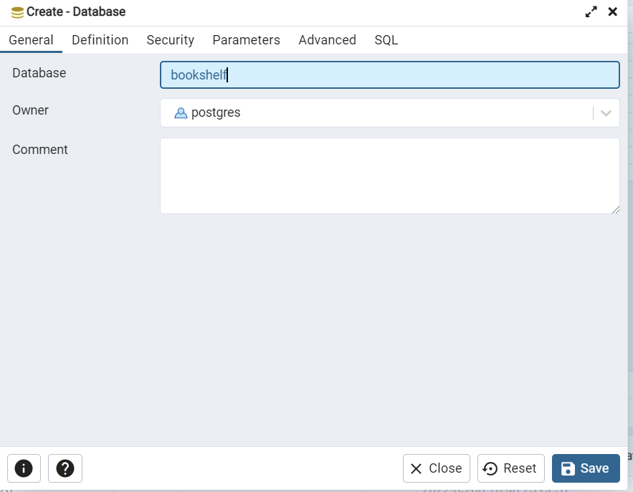

That’s all from pgadmin. Database ‘bookshelf’ should looks like this.
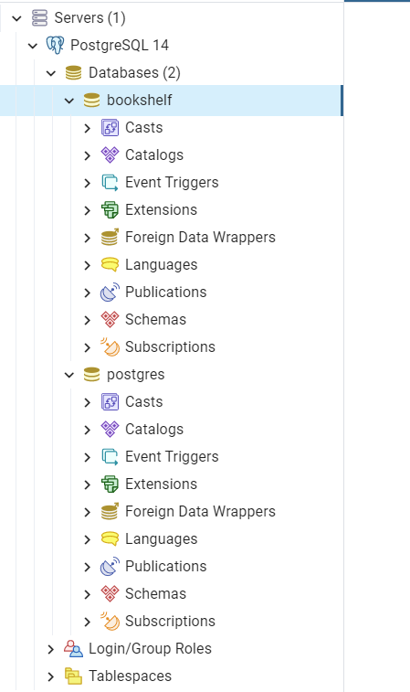
- cmd
1. Copy path to bin folder of PostgreSQL

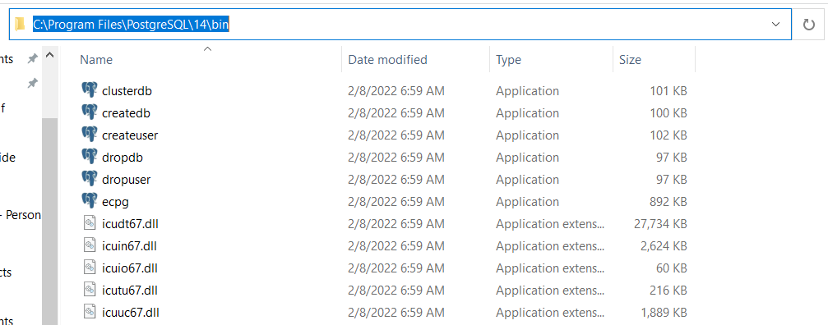

2. Open cmd and go to bin folder

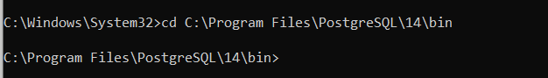

3. Connect to psql with your PostgreSQL account with given command

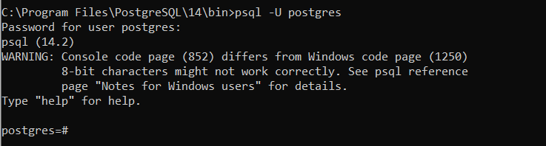
Where ‘postgres’ is the username of the account. After that you have to write a password.

4. Use ‘CREATE DATABASE’ command

Name of the database has to be ‘bookshelf’. After that, just for verification of ‘bookshelf’ creation, use meta-command ‘\list’ or shortcut ‘\l’.

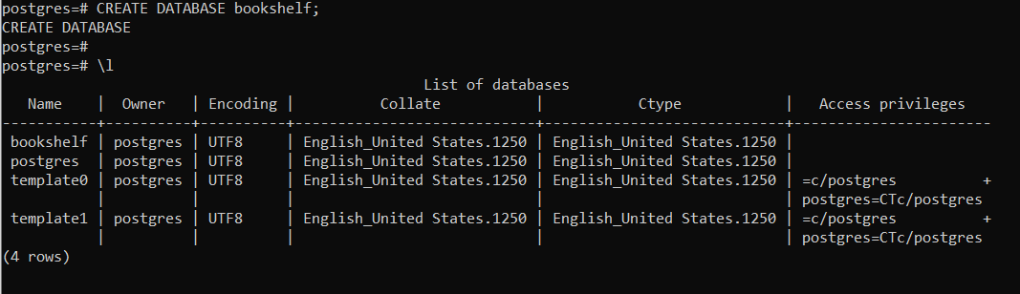
After that your database is ready to go.

- application.yml configuration
To run database in application correctly, you have to change username, password in application.yml file
(remove username, password and write your own personal data where red underlines are)

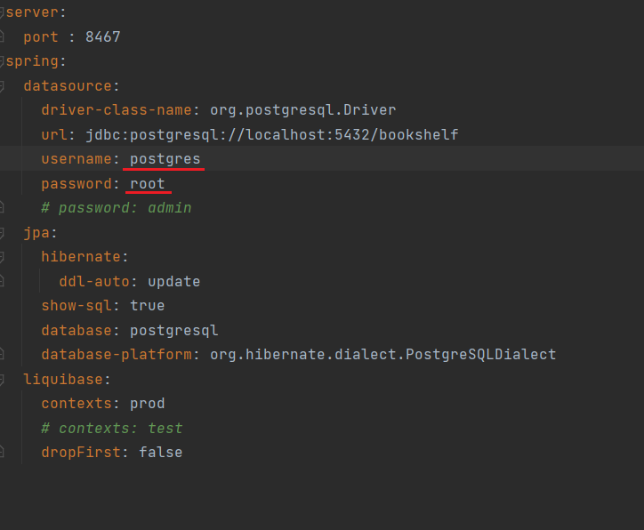
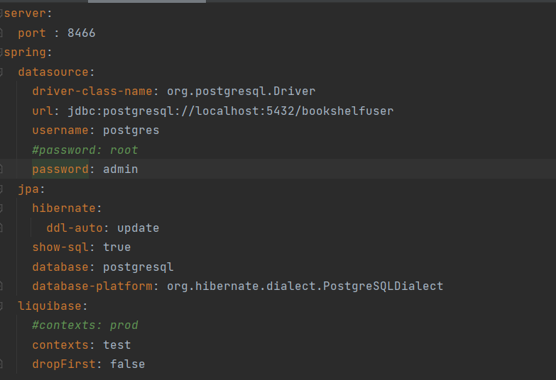
4. Liquibase contexts

The application provides two database contexts

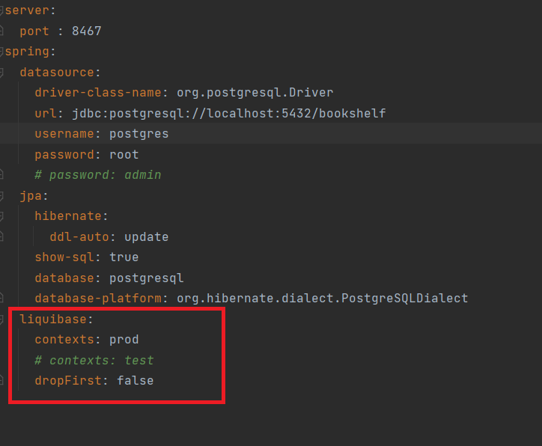
When you want to your database without any data, just setup of the entities, use prod contexts.
On the other hand, when you want your database to start with defined data in it, use test context.

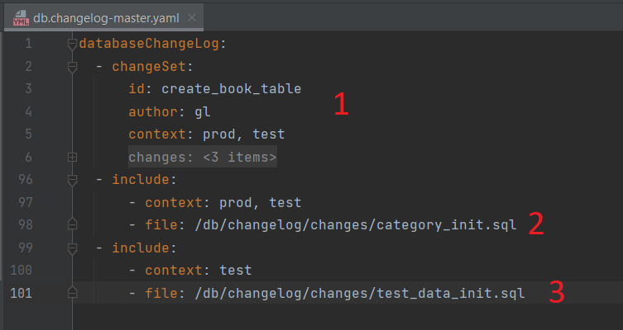

1. Structure of the database (entities, foreign keys etc.)
2. Starting categories (has to be in both contexts)
3. Test data (only in test context)

You can edit your test data in changes/test_data_init.sql file

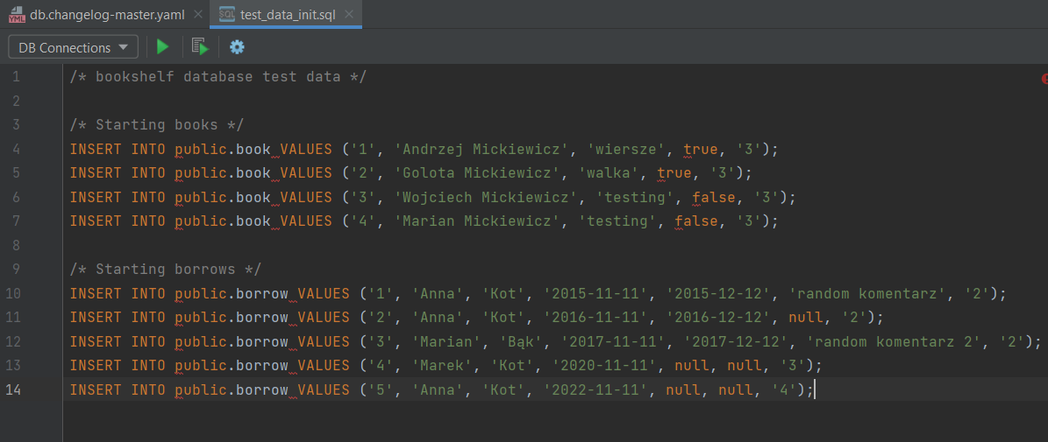

To verify if test context works, change context of the application in application.yml to contexts: test

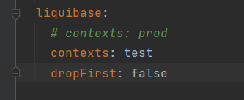
After that search for inserted data in your database (pgadmin 4).

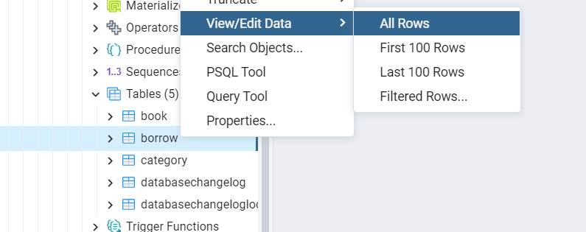
There are test data, now you are able to data processing

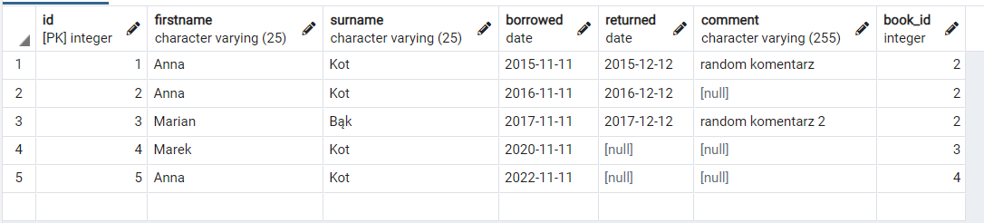

5. Additional information

- Code coverage level = 75% and above
- Use JavaDocs to describe classes and methods
- Meaningful commits descriptions (use git squash, avoid git merge)

